HOLY CROSS BEHAVIOURAL EXPECTATIONS
Our Holy Cross Behaviour Support Guidelines outline the behavioural expectations for students that contribute to a safe and supportive learning environment.

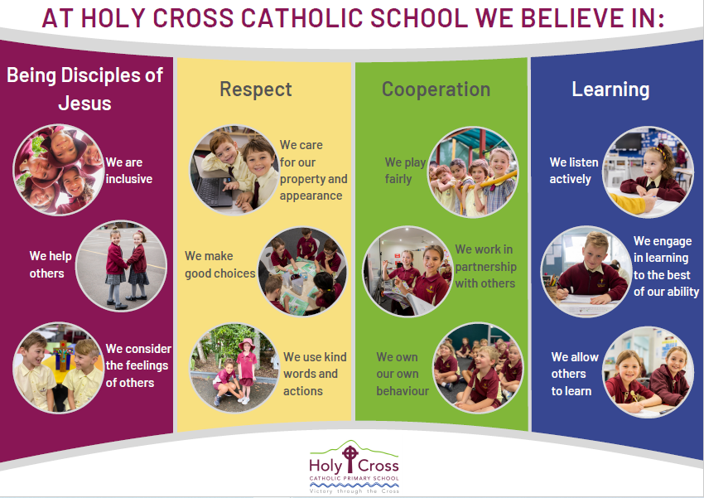

PBIS Framework

The whole school approach is based on the Positive Behavioural Interventions and Supports (PBIS) Framework, also known as Positive Behaviour for Learning – PBL. It focuses on creating and sustaining a multi-tiered approach to prevention and intervention for behaviour. See Appendix for further details.

PROCEDURES FOR TEACHING AND COMMUNICATING BEHAVIOURAL EXPECTATIONS
Holy Cross implements a positive behaviour schoolwide system approach that includes proactive strategies for defining, teaching, and supporting appropriate student behaviour.

Our expectations are:
- explicitly taught during class time
- outlined during Monday morning assemblies;
- referred to during all aspects of school life;
- promoted through our Kindness Ambassadors, allocated from each class;
- displayed through our Random Acts of Kindness Nominations and Awards;
- encouraged by our SRC and student leaders;
- incorporated in PDH programs using resources such as Worry Woos, Friendly Schools, Zones of Regulation, Rock and Water

PROCEDURES FOR ENCOURAGING POSITIVE BEHAVIOUR
The Holy Cross community is committed to acknowledging positive behaviour through the following strategies:

- Verbal acknowledgement – recognition of how behaviours affect others, single word utterances, praise, descriptive encouragement identifying the behaviour etc;
- Non–Verbal acknowledgement – smile, gestures, nod, thumbs up, proximity etc;
- All class teachers will be explicitly teaching and rewarding behaviours that are consistent with our school values - ‘Being disciples of Jesus’, ‘Respect’, ‘Cooperation’ and ‘Learning’. When a student is ‘caught’ displaying a positive behaviour, they are rewarded a point. Teachers will display these points as a tally on the white boards at the front of the classroom. The SRC representatives will collect all classroom points each week and collate them as a whole school amount. When the whole school has reached a particular set amount of points a reward will be given to the whole school.
Suggested whole school rewards:

Points | Possible Rewards | 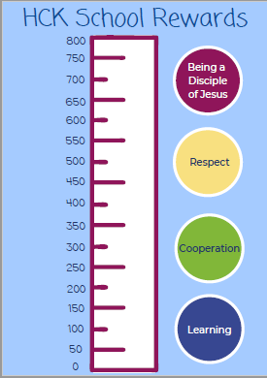
200 | 10 minutes extra play, 10 min in class activity of choice eg. mindfulness colouring, craft, game, free time, listen to music
400 | 15 minutes extra play, 15 min in class activity of choice eg. mindfulness colouring, craft, game, free time, listen to music, paper aeroplane competition, slipper day
600 | 20 minutes extra play
800 | sports fun afternoon, mufti day, movie afternoon, ice blocks, end of day disco, sausage sizzle

- All classrooms will display the school values posters in their rooms and regularly refer back to them while teaching.
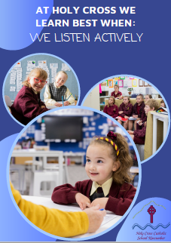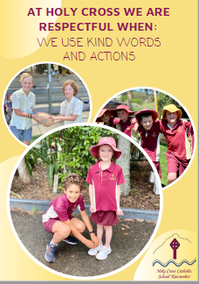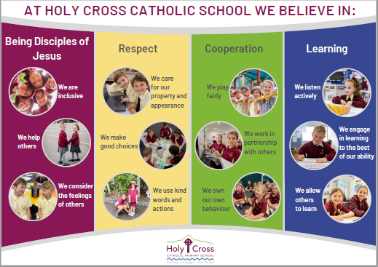

- Each class teacher may develop their own systems of acknowledgement and reinforcement within their class that are student focused; both intrinsic or extrinsic methods can be implemented. Intrinsically motivated positive behaviours for learning is our goal, however we recognise that some students require additional support to achieve positive behaviour for learning through extrinsic motivation; the gradual release of such rewards is key to developing intrinsically motivated students. These rewards systems should have a connection to the whole school rewards to maintain a consistent whole school approach.
At every effort, staff will recognise and acknowledge the efforts from all students in their class whether it is in the academic, sporting, social or behavioural
areas. A major focus will be on the PBL/ school value focus that the classroom teacher is working on at that particular time.
- Comments in student workbooks;
- Being chosen for responsibilities;
- Class visits sharing of work/achievements;
- Public acknowledging appropriate behaviours from groups of students at assemblies;
- Merit Awards – These Awards (two each class) will be presented at an assembly in weeks 3, 6, 9 and 11; Class teachers, Teacher librarian, Learning Support Staff, Music teacher, PE teacher, Japanese teacher and Admin staff may nominate children for Merit Awards, and these may be given in collaboration with the class teacher. One of these awards will be linked to our school values.
- Behaviour Expectations and the Behaviour Consequence Matrix (see below) will be displayed in all classrooms. Students will be introduced or reminded of these documents at the beginning of each year and regularly referred to throughout the school year.

OUR BEHAVIOUR MANAGEMENT GUIDELINES IS COMMUNICATED TO THE SCHOOL COMMUNITY
- included in orientation information to students and families;
- displayed in the classroom, the playground, school website;
- added to our parent memo.

PROCEDURES FOR DISCOURAGING INAPPROPRIATE BEHAVIOUR
Holy Cross Behaviour Support Guidelines are based on restorative principles that support students to restore right relationships and re-engage in learning. These procedures are respectful of the dignity, rights and fundamental freedoms of individual students, and at the same time are focused on the effective running of the school for the benefit of all.

Our focus is to take a proactive and positive approach to behaviour. Expected behaviours will be explicitly taught and reinforced throughout the year as required, based on data collected.

Strategies to assist students’ positive behaviour include:
- targeted social skills instruction;
- increased adult monitoring and positive attention;
- specific/regular daily feedback;
- progress monitoring of behavioural goals for students on behaviour plans

Staff are to be aware and implement the Inappropriate Behaviour Consequence Flow Chart consistently to determine teacher managed inappropriate behaviours and school leadership referred inappropriate behaviours.

HCK Behaviour Consequence Matrix
Level One | Level Two | Level Three | Level Four
Learning and Engagement  - Not engaging in/interrupting in learning activities  - ·Task refusal, task avoidance  - Calling out  - Leaving class without permission  Respect  - Failure to respond to teacher request  - Low intensity misuse of school or personal property, including littering or not picking up paper around you.  Respect for our Appearance  - School uniform is worn inappropriately  Cooperation  - Non-intentional inappropriate physical contact e.g., rough play  - Minor inappropriate language | Learning and Engagement  - Frequent inappropriate interruption to learning  - Refusing to do work  Respect  - Frequent failure to respond to teacher request  - Frequently answering back to teacher  - Shows disrespect towards students, teachers and others (verbal & nonverbal)  Cooperation  - Intentional/low level physical contact where injury may/may not occur e.g., pushing through frustration, throwing an object etc  Technology Misuse  - Using technology (computers, phone, smart watch etc) without permission  Also, Ongoing repeated Level 1 behaviour | Learning and Engagement  Repeated on going off task behaviours  - Off task behaviours occurring for long periods of time or repeated over time (long duration, high frequency).  Technology misuse  - Misuse of technology (phone, iPod, camera, smartwatches, computer, iPad, etc) which is sustained or (potentially) harmful to others including misuse of social media at home  Respect for Others  - High intensity failure to respond to teacher request  - Answering back to teacher  - Disrespect towards other students/teachers including swearing (verbal & nonverbal)  Physical Aggression  - Physical contact where injury may/has occurred e.g., hitting, punching, kicking, fighting  Ongoing repeated Level 2 behaviour  3 x short time-outs given for similar incidents within a 5-week period | Abusive Language  - Verbal aggression such as swearing, prolonged name calling, threats, continued intimidation including social media, prolonged use of put downs  Respect for Others  - Repeated refusal to follow reasonable requests/directions  Respect for Property  - Substantial destruction or disfigurement of personal, school or others property e.g. graffiti  - Having possession of or removing property belonging to someone else  Leaving School Grounds without Permission  Respect for Others -Bullying  - on-going harassment (refer to Diocesan Bullying Policy).
Consequences | Consequences | Consequences | Consequences
- Remind  - Reteach  - Redirect  - Remove (to predetermined in class time out/or buddy class this is a cool down time meant to diffuse the situation) | - Minor Think Sheet Short time out (15 – 30 mins) in the classroom or in the playground.  - Data recorded on Compass Behaviour Chronicle (Minor)  - Class teacher was notified via Compass  - Minor Think Sheet Doc sent home signed and returned. Contact will depend on the request. | - Major Think Sheet to be completed in the executive office (playground) or in classroom (learning) 30 – 60 mins time out  - Data recorded on Compass Behaviour Chronicle (Major) by teacher  - Major Think Sheet sent home to parents for signature and returned. Uploaded onto student file in Compass  - Follow through with any communication requests on Think Sheet. Contact will depend on the request. | PHASE 1  - Long time-out in classroom, playground or Executive office (to determine by teacher and executive)  - Data recorded on the Compass Behaviour Chronicle  - Think Sheet completed and sent home.  - Executive to call parents.  PHASE 2  Meeting with principal, teacher, student & parent/s.  Behaviour Plan to be developed & communicated to staff & parents. Ongoing Level 4 behaviours refer to Diocesan Policy re suspension, transfer, and expulsion.
PROCEDURES FOR RECORD KEEPING AND MONITORING
Holy Cross collects data to inform planning for whole school systems as well as individual interventions to encourage positive behaviour. This includes:

- Electronically recording behaviour incidents on the Compass Behaviour Chronicles collecting data including time, date and location of the incident, the child’s name, class, teacher and other persons involved;
- Behaviour is monitored by the Behaviour and Wellbeing Team. The team meets twice a term to review data collected concerning behavioural incidents which allows the discernment of patterns, triggers and/or timing. Prevention and intervention strategies are discussed and planned; This information will be fed back to the school staff regularly at communication meetings.
- At Level 3 and 4 Long Time Out Reflection sheets are allocated to students to reflect on their behaviour by the leadership team. This will be sent home and also placed in the student file once returned.

PROCEDURES FOR RESPONDING TO CHALLENGING/AT RISK BEHAVIOURS
Challenging or at-risk behaviour is any behaviour that significantly impacts on the day-to-day functioning of schools. Challenging or at-risk behaviour is best understood as a continuum which ranges from students’ requiring universal classroom-based support, to the most complex social and emotional needs requiring an individualised approach. Our school implements the following strategies to support and manage challenging/at risk behaviour.

Students displaying challenging or at-risk behaviour can be identified by teachers or from data collected from the Behaviour Incident Tracking Form. This information is collected by the Behaviour and Wellbeing Team and intervention strategies will be developed in collaboration with the classroom teacher.
Possible intervention strategies for challenging/at risk behaviour include:

- Seeking advice from support services, for example; School Counsellor, Learning Support Teacher, School Leadership Team, CSO Pastoral Care and Wellbeing Team, Special Needs Team, Community Mental Health Support Teams;
- Behaviour Management Support Plans;
- Student Counselling.

Procedures for serious breaches of behaviour such as Suspension, Negotiated Transfer, Expulsion and Exclusion are outlined in the Diocesan Behaviour Support Policy.

Serious Incidents

Under certain circumstances, staff may be required to make a response to a serious incident presented by a student. Emergency and critical incident responses may be required and include procedures for emergency evacuation, lock down procedures, or first aid. Serious incidents will be managed by the school leadership team and documented in the school incident record file. Critical incident management is informed by the CSO Guide for Managing Critical Incidents in Schools.

Principals will notify the FACs, NSW Police, the CSO Child Protection Team or the CSO Wellbeing Team as required.

ROLES & RESPONSIBILITIES-The following table highlights the roles and responsibilities of key stakeholders.
Principal/Leadership Team | Staff | Student | Parents | Catholic Schools Broken Bay
Ensure a safe, secure and harmonious learning environment for students and staff  Monitor the implementation of the DSS Behaviour Support Policy and school Behaviour Support Guidelines  Ensure staff are provided with training and development opportunities in behaviour management as required  Ensure that students receive explicit instruction on the school’s behavioural expectations/school rules  Ensure records of behaviour incidents will be kept systematically by the school and regularly analysed to identify patterns and proactive support for positive behaviour  Provide access to the DSS Behaviour Support Policy and school Behaviour Support Guidelines  Ensure that all major disciplinary actions involving suspension, transfer, expulsion or exclusion from school are managed in accordance with procedures outlined in the DSS Behaviour Support Policy. | Implement the DSS Behaviour Support Policy and school Behaviour Support Guidelines  Respect and support students  Model appropriate respectful behaviour  Use pedagogical practices that promote a safe and supportive learning environment to optimise learning and wellbeing  Respond in a timely manner to incidents of inappropriate/challenging/or at-risk behaviour according to the school’s Behaviour Support Guidelines. | Act appropriately, respecting individual differences and diversity  Act as responsible digital citizens  Follow the school behavioural expectations (rules)  Act as responsible bystanders or ‘up-standers’ for others who are being disrespected  Report incidents of inappropriate/challenging/or at-risk behaviour to teachers/school counsellor  Seek support if they need help with behaviour or relationship matters such as, resilience, bullying or cyberbullying incidents. | Support the DSS Behaviour Support Policy and Sustaining Strong Catholic School Communities Policy and school Behaviour Support Guidelines  Treat all members of the school community with dignity and respect  Support their children to adopt positive pro-social behaviours (inclusive of online behaviour)  Work collaboratively with the school to resolve behaviour matters  Report incidents of inappropriate/challenging/or at-risk behaviour according to the school’s guidelines | Support schools to implement the DSS Behaviour Support Policy and school Behaviour Support Guidelines  Provide support to Principals in the management of challenging/or at risk behaviour.

